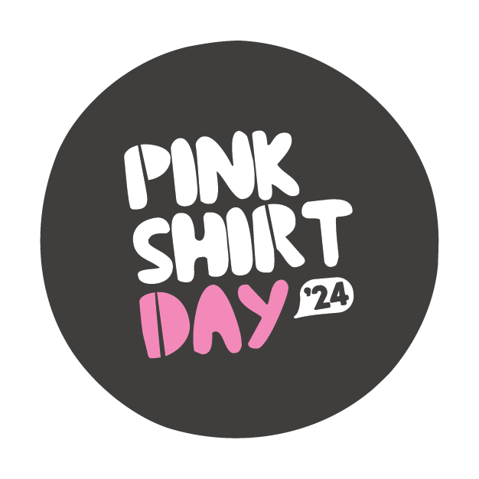

Pink Shirt Day:

Friday 17 May 2024

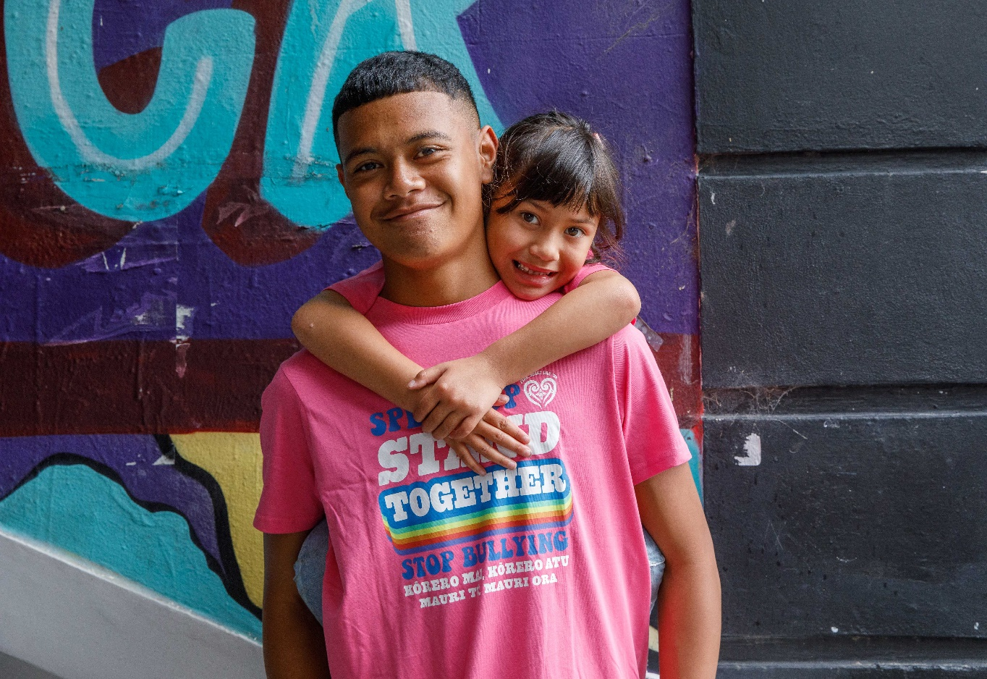

Published: March 2024

# What is Pink Shirt Day?



This is Easy Read information about Pink Shirt Day.

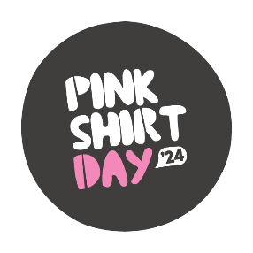

Pink Shirt Day is a day every year to:

stand up against **bullying**

celebrate **diversity**

be:

* 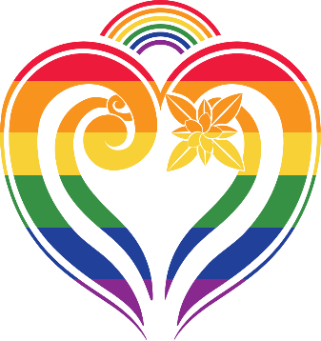inclusive– make sure everyone is part of things
* kind.

**Bullying** is when 1 person or a group of people treats someone in a bad way.



Bullying can be when someone:

says nasty things to you / about you:

* in person
* online – this is called cyberbullying

ignores you or leaves you out

hits you / kicks you / pushes you

tells lies about you.

**Diversity** means all the things that make people different from each other like their:

culture

age

religion

**sexuality**

**gender**.



**Sexuality** is things like:

* who you are attracted to
* 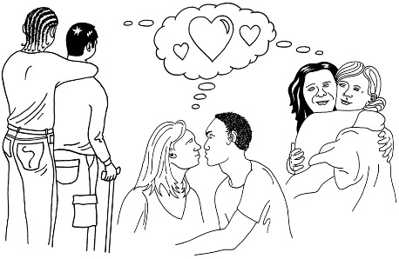who you want to be in a relationship with
* if you want to be in a relationship or not.

**Gender** is if you are:

a woman

a man

another gender like nonbinary.

This year Pink Shirt Day is on

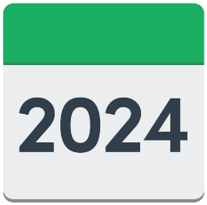

**Friday 17 May 2024**.

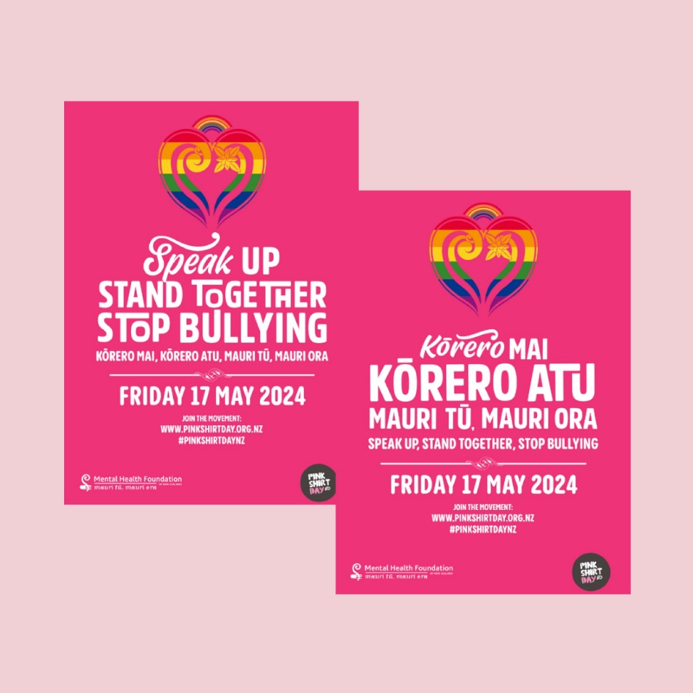

Pink Shirt Day has happened in Aotearoa New Zealand every year since 2009.

# How you can take part in Pink Shirt Day

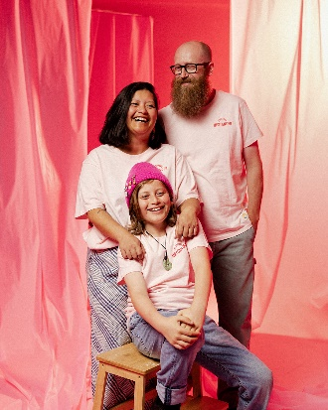There are different ways you can take part in Pink Shirt Day like:

wearing a pink t-shirt / top

having an event to raise money for Pink Shirt Day.



You can find more ideas on the Pink Shirt Day website:

**www.**[**pinkshirtday.org.nz**](https://pinkshirtday.org.nz/)

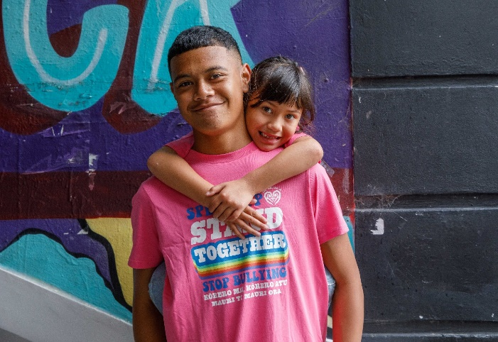Pink Shirt Day t-shirts will be available at **Cotton On** shops around Aotearoa New Zealand.

You can buy these t-shirts a few weeks before Pink Shirt Day.

The Pink Shirt Day website has free information about bullying for:

schools

workplaces

communities.



This information can be used to have spaces that:

welcome everyone

are safe

do not allow bullying.

You can sign up online for updates about:

information on events you can run

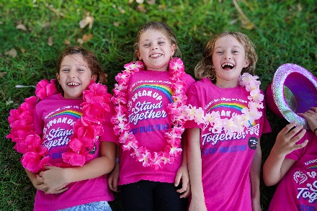information that you can download

when Pink Shirt Day t-shirts are available to buy at Cotton On stores.



You can sign up here:

[**shorturl.at/egpLO**](https://shorturl.at/egpLO)

# Where to find more information

You can find more information about Pink Shirt Day at this website:

**www.**[**pinkshirtday.org.nz**](https://pinkshirtday.org.nz/)

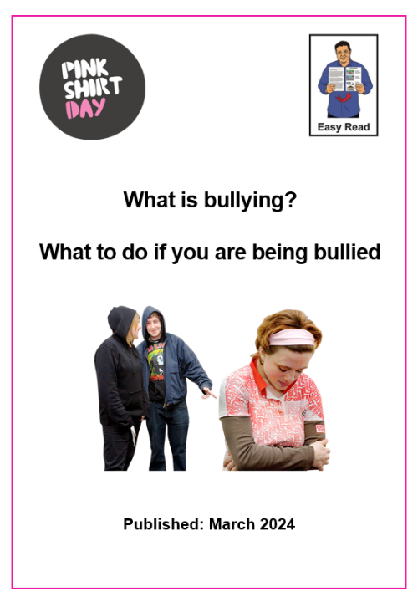

There is also an Easy Read document called:

**What is bullying?**

**What to do if you are being bullied**

You can find this Easy Read document at:

[**https://pinkshirtday.org.nz/resources/easyreadwhatisbullying**](https://pinkshirtday.org.nz/resources/easyreadwhatisbullying)

This information has been written by the Mental Health Foundation of New Zealand.

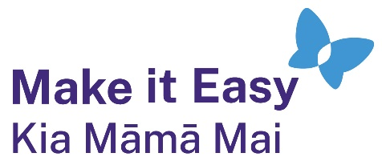It has been translated into Easy Read by the Make it Easy Kia Māmā Mai service of People First New Zealand Ngā Tāngata Tuatahi.



The ideas in this document are not the ideas of People First New Zealand Ngā Tāngata Tuatahi.



Make it Easy uses images from:

* Photo SymbolsChangepeople.org

Photosymbols.com

* SGC Image Works
* Huriana Kopeke-Te Aho
* T. Wood.

  
All images used in this Easy Read document are subject to copyright rules and cannot be used without permission.