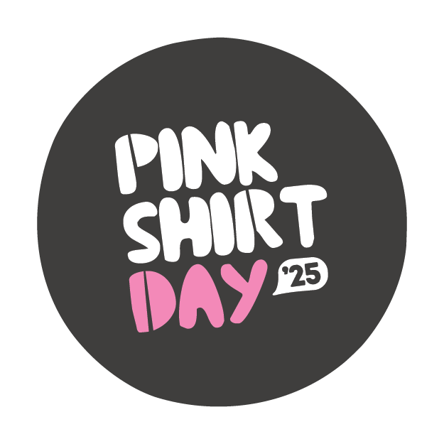
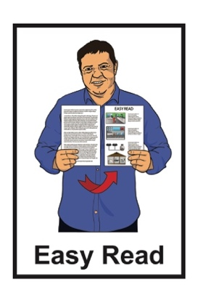

Pink Shirt Day:

Friday 16 May 2025
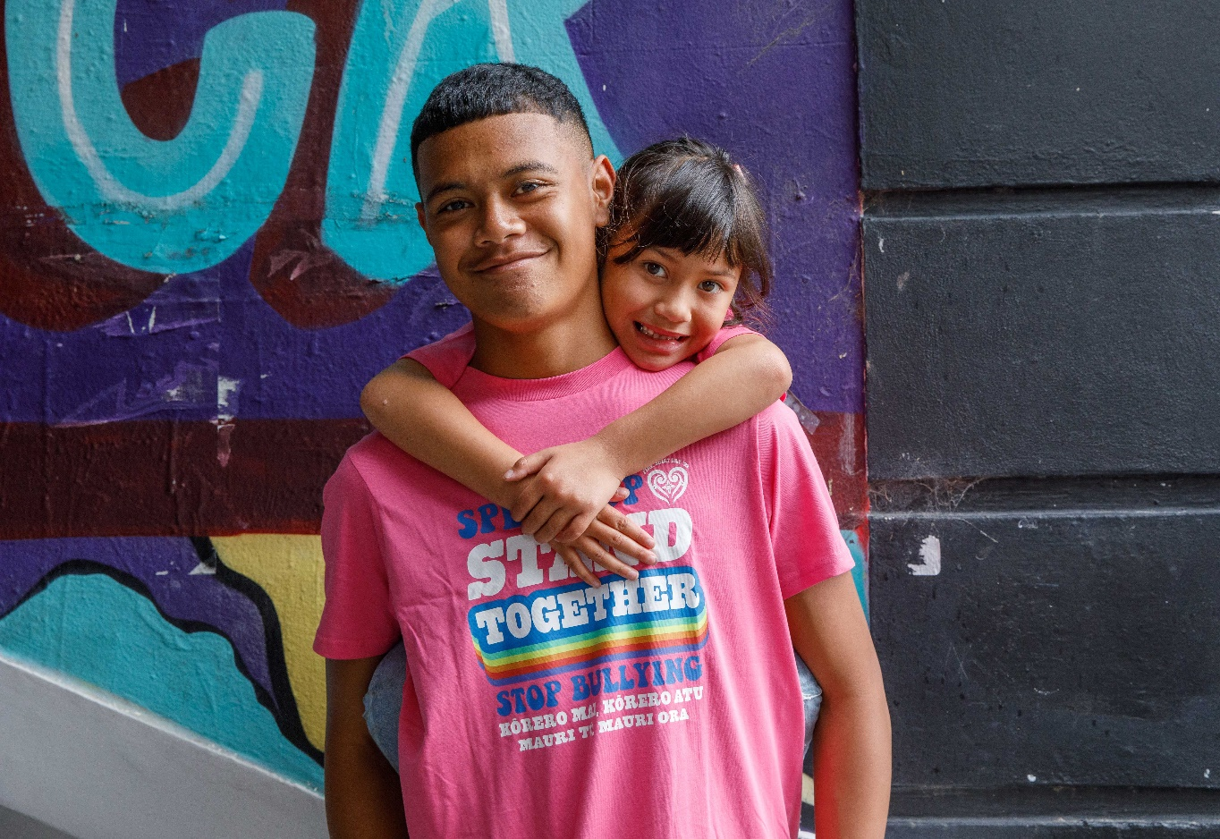

Updated: March 2025

What is Pink Shirt Day?


This is Easy Read information about Pink Shirt Day.
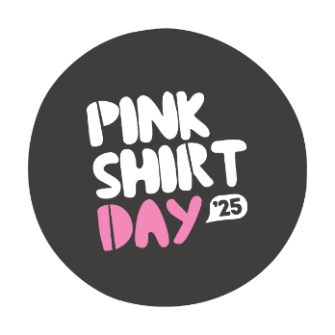

Pink Shirt Day is a day every year to:
stand up against bullying
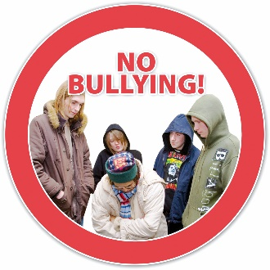
celebrate diversity
be:
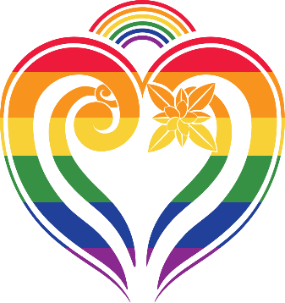
- inclusive – make sure everyone is part of things
- kind.


Bullying is when 1 person or a group of people treats someone in a bad way.


Bullying can be when someone:
says nasty things to you / about you:

- in person
- online – this is called cyberbullying

ignores you or leaves you out
hits you / kicks you / pushes you
tells lies about you.


Diversity means all the things that make people different from each other like their:
culture

age
religion
sexuality
gender.


Sexuality is things like:
- who you are attracted to
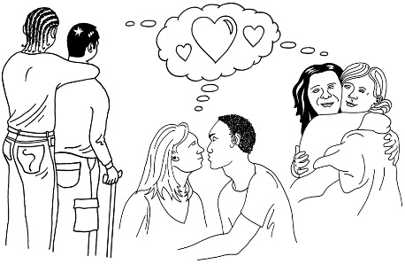
- who you want to be in a relationship with
- if you want to be in a relationship or not.

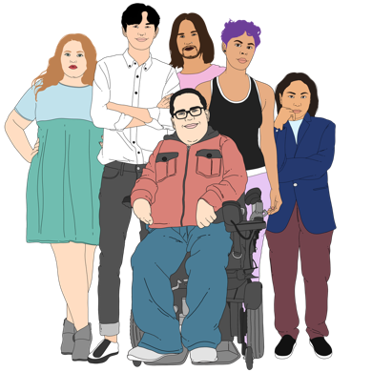
Gender is if you are:
a woman
a man
another gender like nonbinary.



This year Pink Shirt Day is on
Friday 16 May 2025.

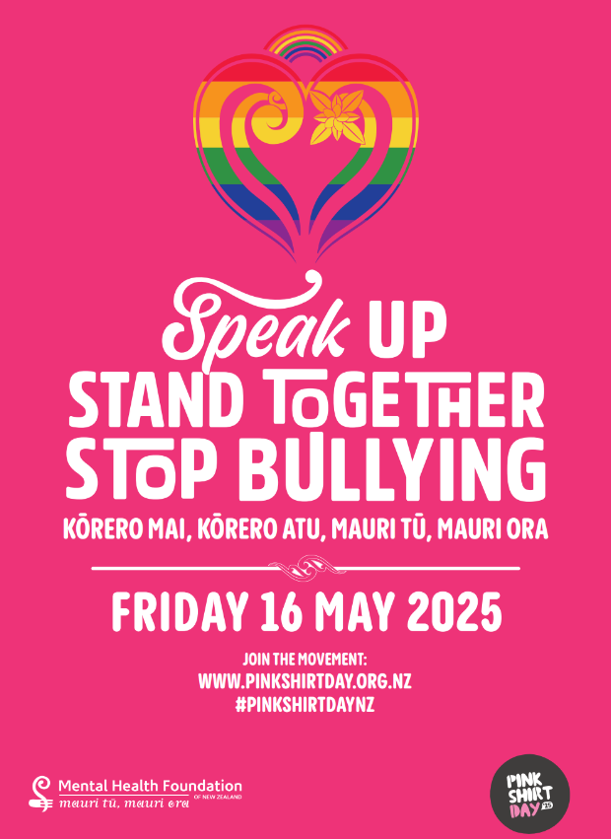
Pink Shirt Day has happened in Aotearoa New Zealand every year since 2009.

How you can take part in Pink Shirt Day

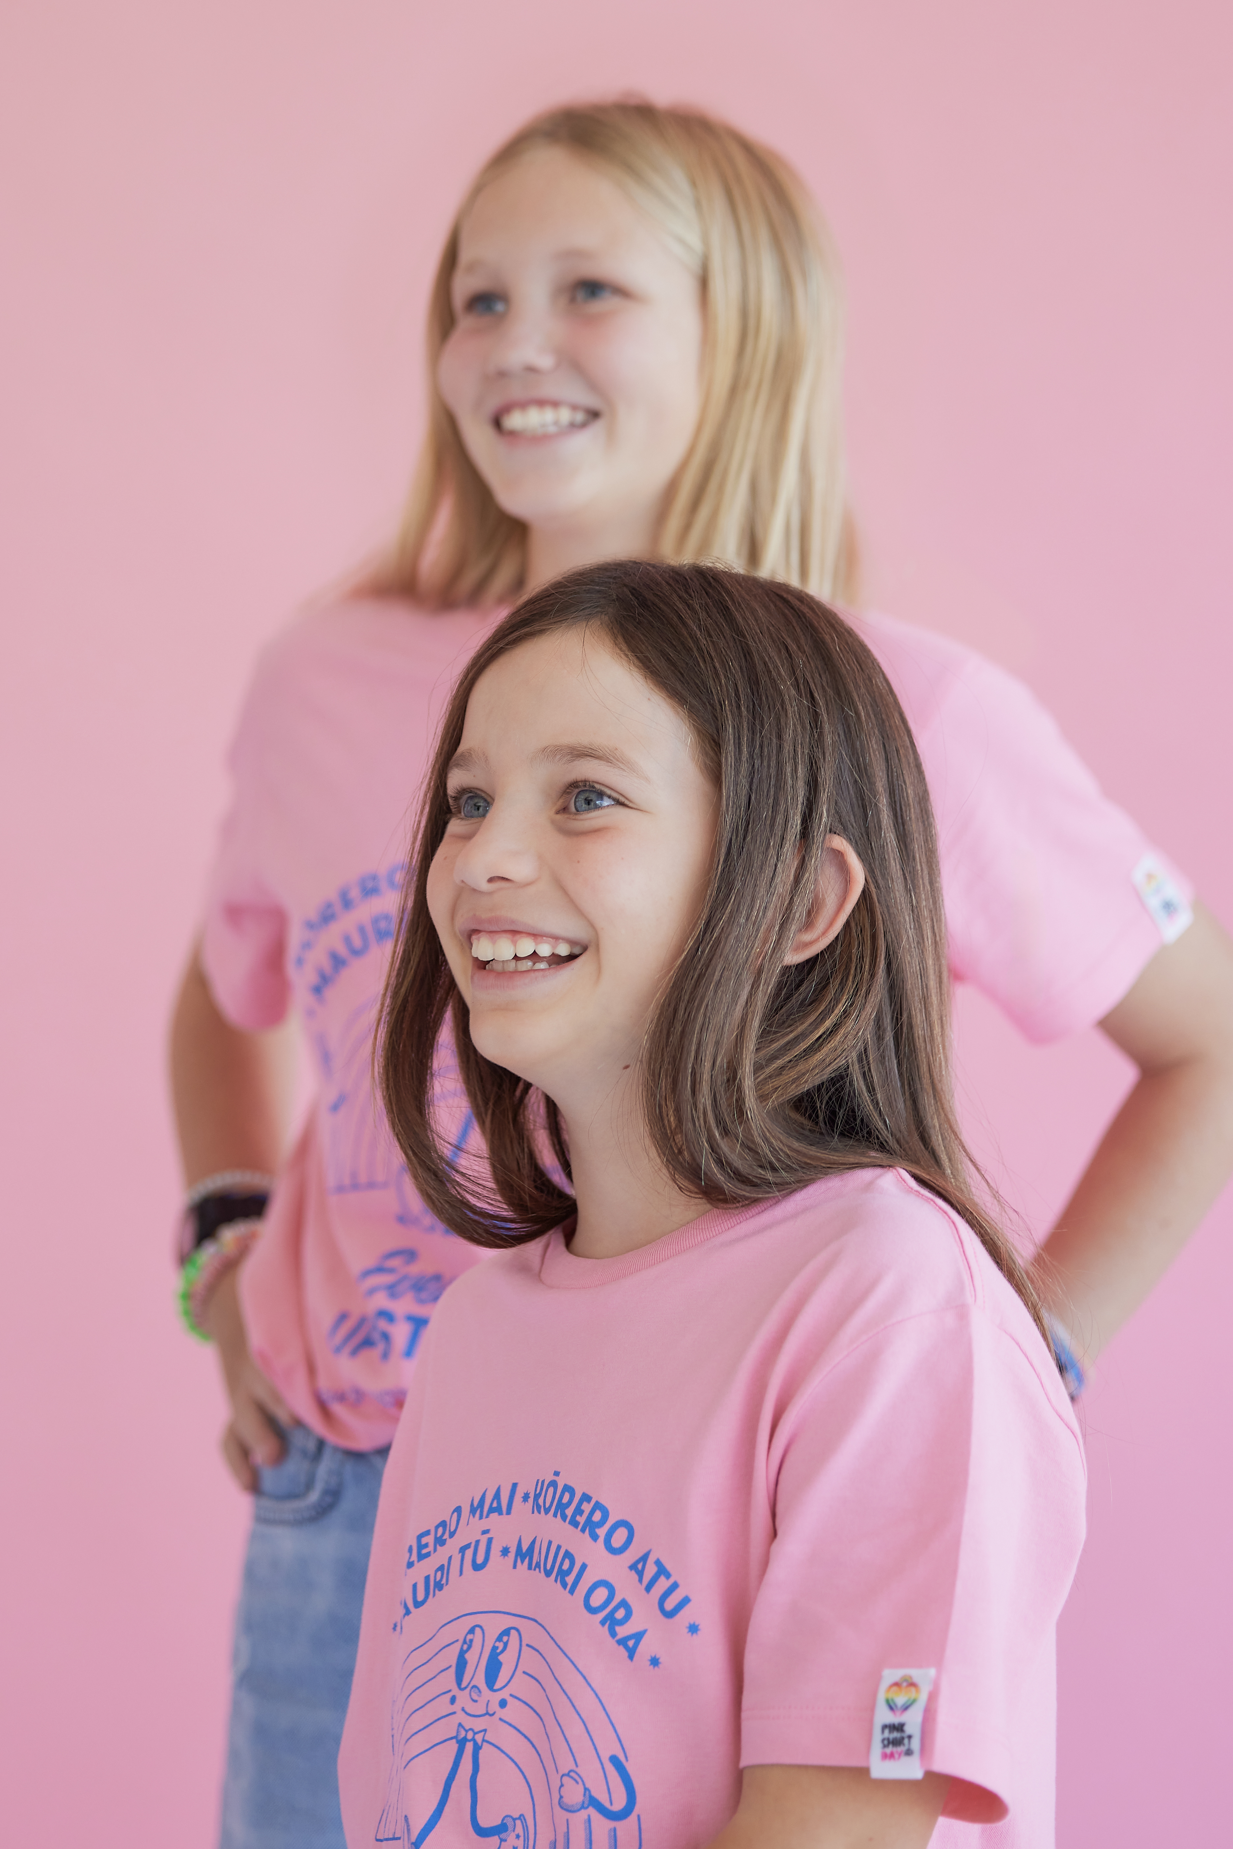
There are different ways you can take part in Pink Shirt Day like:
wearing a pink t-shirt / top
having an event to raise money for Pink Shirt Day.


You can find more ideas on the Pink Shirt Day website:

www.pinkshirtday.org.nz


Pink Shirt Day t-shirts will be available at Cotton On shops around Aotearoa New Zealand.

You can buy these t-shirts a few weeks before Pink Shirt Day.
The Pink Shirt Day website has free information about bullying for:
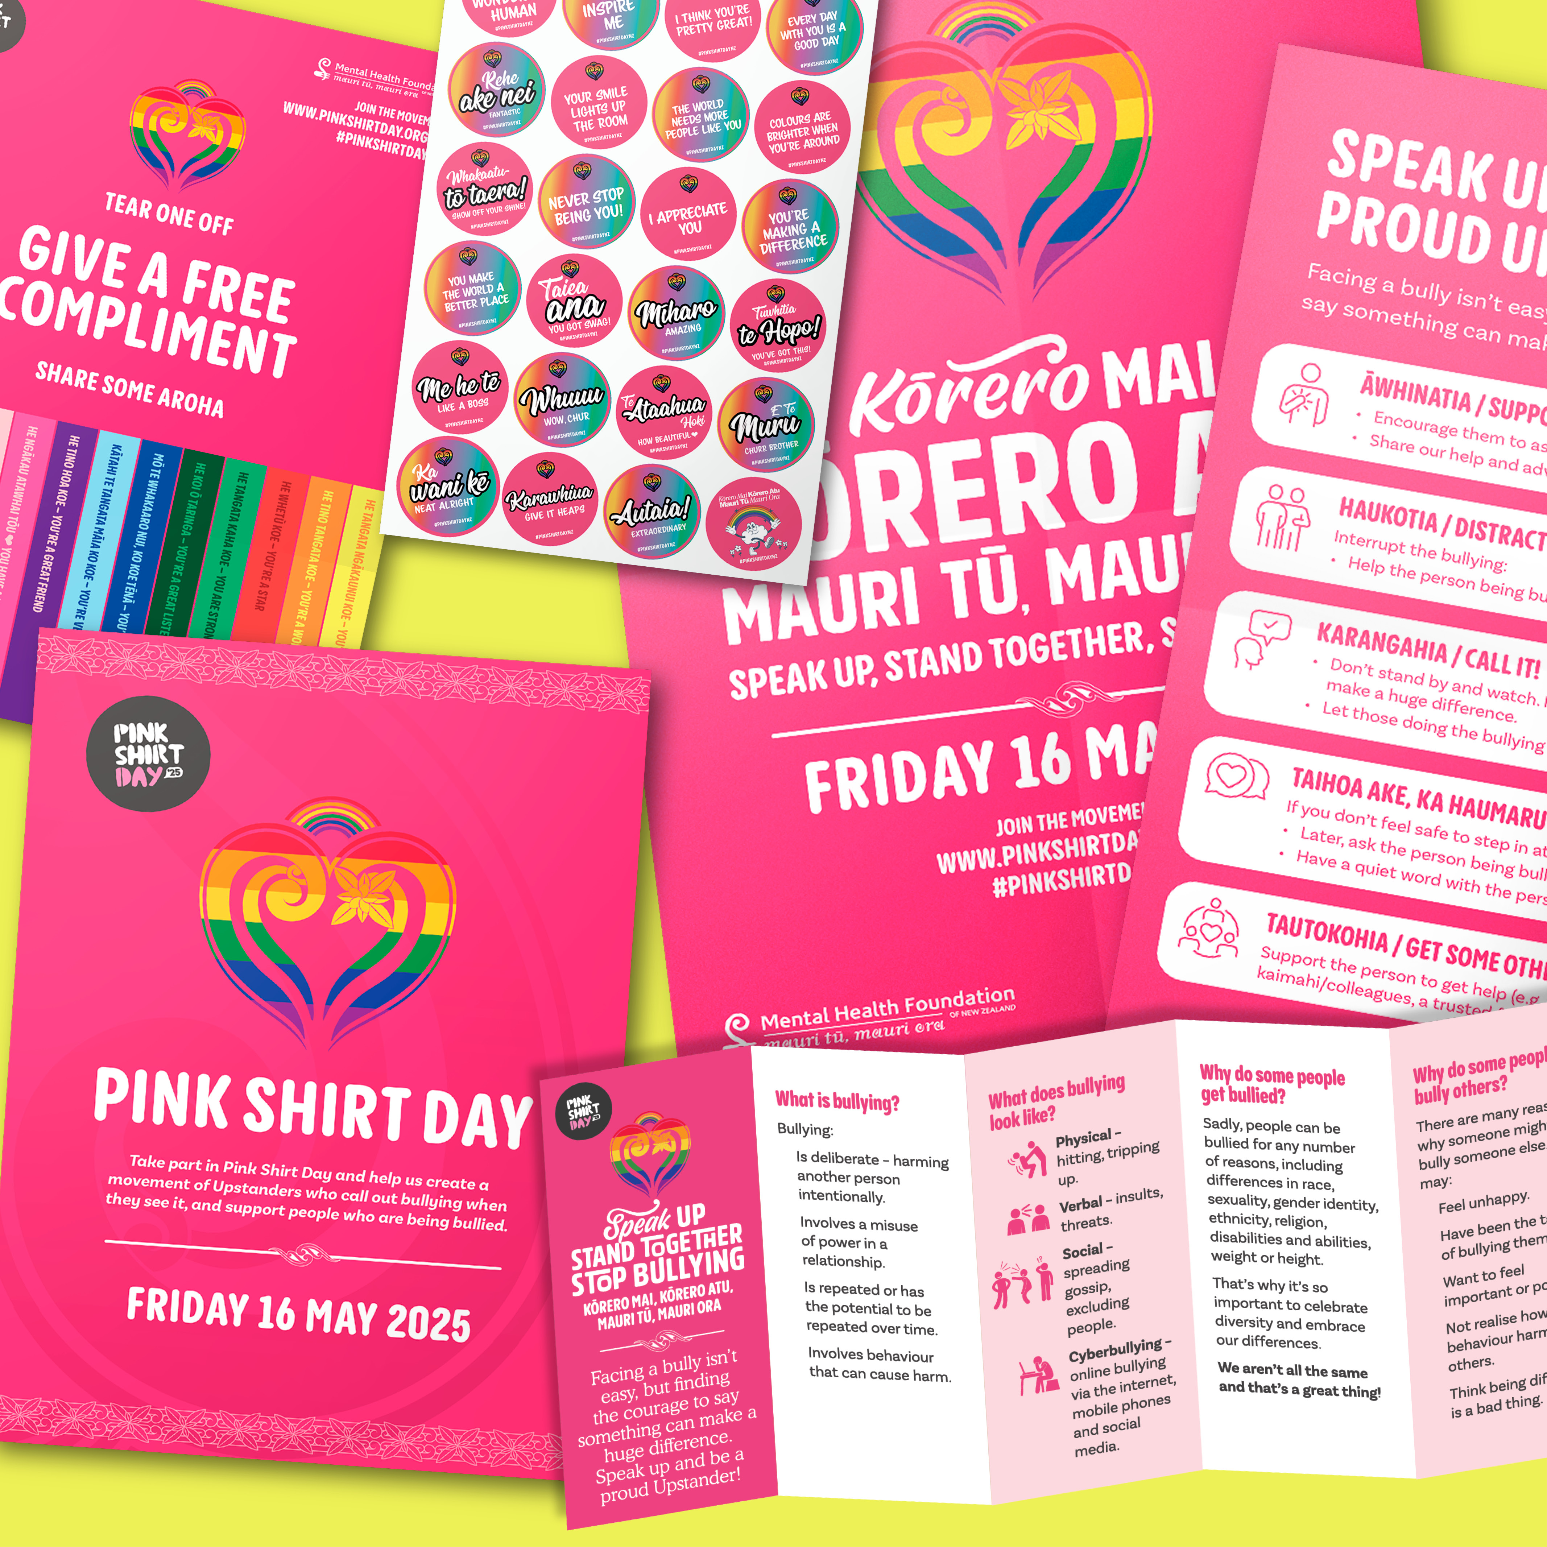
schools
workplaces
communities.


This information can be used to have spaces that:

welcome everyone
are safe
do not allow bullying.


You can sign up online for updates about:
information on events you can run

information that you can download
when Pink Shirt Day t-shirts are available to buy at Cotton On stores.

You can sign up here:
shorturl.at/egpLO

Where to find more information

You can find more information about Pink Shirt Day at this website:

www.pinkshirtday.org.nz

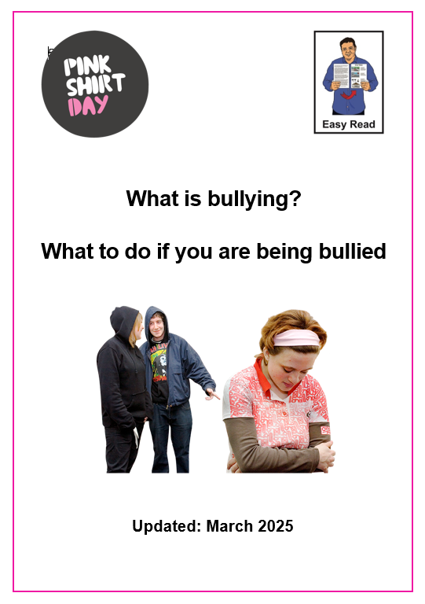
There is also an Easy Read document called:

What is bullying?

What to do if you are being bullied

You can find this Easy Read document at:

https://pinkshirtday.org.nz/resources/easyreadwhatisbullying


This information has been written by the Mental Health Foundation of New Zealand.

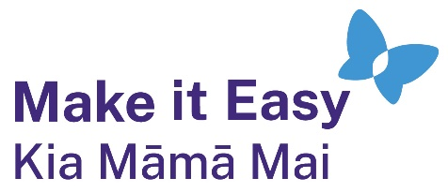
It has been translated into Easy Read by the Make it Easy Kia Māmā Mai service of People First New Zealand Ngā Tāngata Tuatahi.

The ideas in this document are not the ideas of People First New Zealand Ngā Tāngata Tuatahi.

Make it Easy uses images from:


- Changepeople.org



            - Photosymbols.com

- SGC Image Works
- Huriana Kopeke-Te Aho
- T. Wood.

All images used in this Easy Read document are subject to copyright rules and cannot be used without permission.

