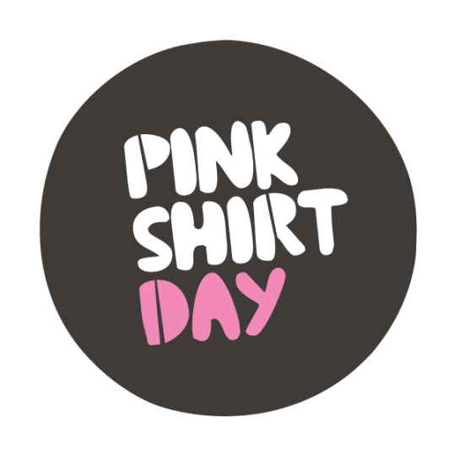
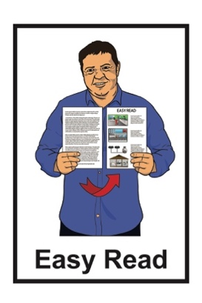
56

What is bullying?

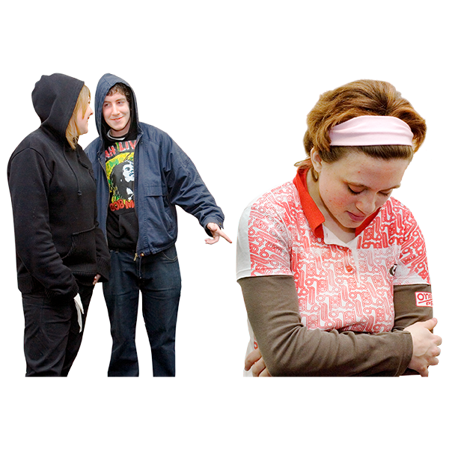
What to do if you are being bullied

Updated: March 2026

What this document is about

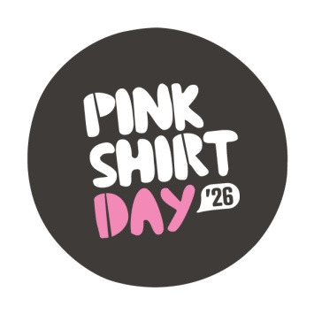
This Easy Read document is part of the information about Pink Shirt Day 2026.


You can find Easy Read information about Pink Shirt Day 2026 at this website:

https://pinkshirtday.org.nz/resources/easyreadpinkshirtday

What is in this document

Page number:

What is bullying? 3

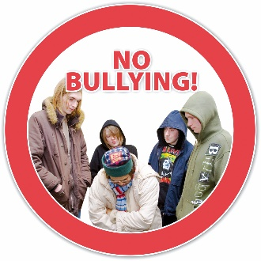
How you can help stop bullying 7

What to do if you are being bullied 14
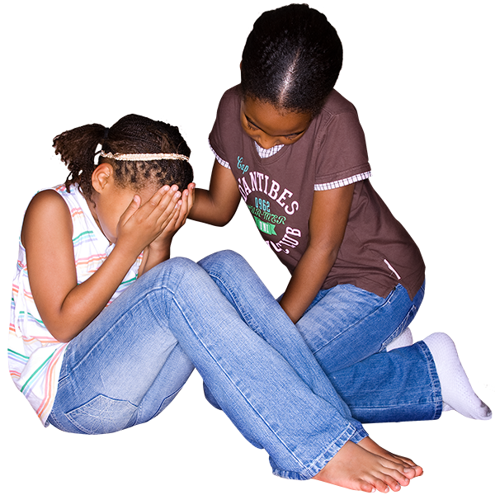

What to do if you are tamariki / child
or rangatahi / young person being
bullied 16


What to do if you are bullied
at work 19


More information 27

What is bullying?
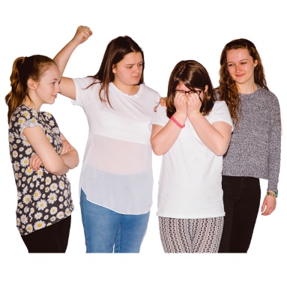

Bullying is when 1 person or a group of people treats you badly.

Bullying can be when someone:
says nasty things to you / about you:
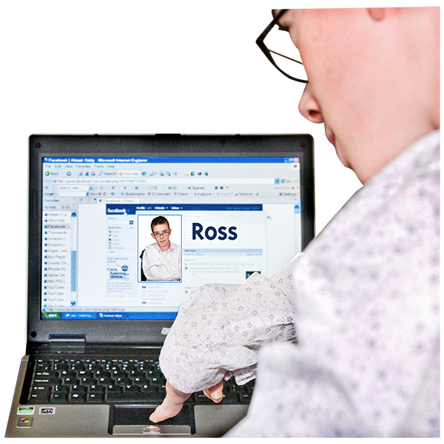
- in person
- online – this is called cyberbullying

ignores you or leaves you out
hits you / kicks you / pushes you.
tells lies about you.

People can be bullied for their differences like their:
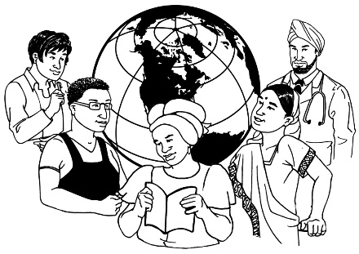
culture / ethnicity – where they are from
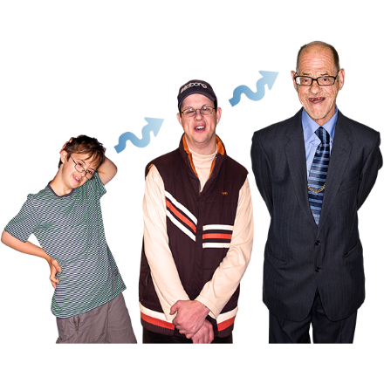
religion
age
sexuality
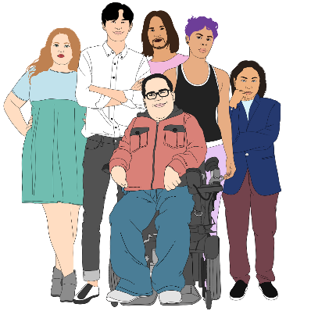
gender
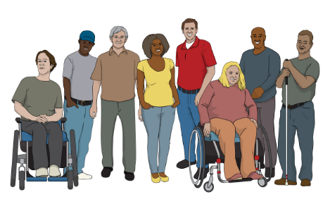
body shape / size
disability.


Sexuality is things like:
/
- who you are attracted to
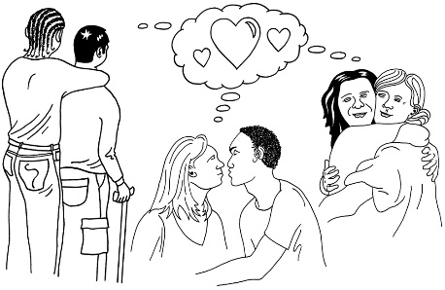
- who you want to be in a relationship with
- if you want to be in a relationship or not.

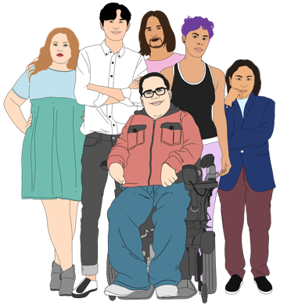
Gender is if you are:
a woman
a man
another gender like nonbinary.

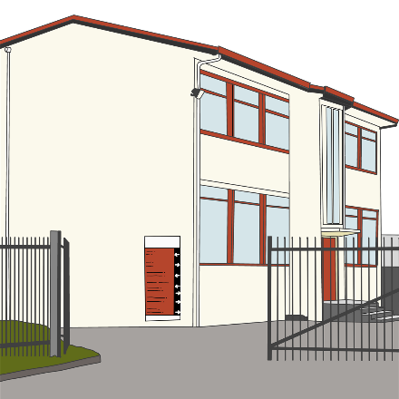
People can be bullied in places like:
schools
workplaces.

Bullying is never okay.

If you are being bullied it is important to remember that:

you are not alone
there are people you can talk to
support is available.

How you can help stop bullying


You can help stop bullying by being an Upstander.

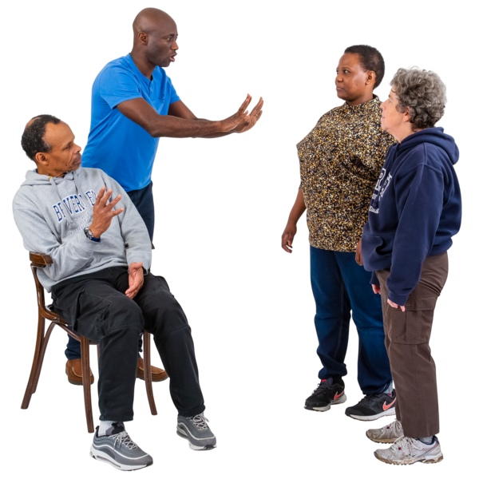
An Upstander is someone who helps stop bullying by:
words they use
actions / things they do.


More information about being an Upstander is available here:

https://pinkshirtday.org.nz/upstander

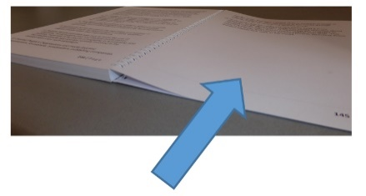
On pages 8 to 15 there is more information about ways you can help someone who is being bullied.

Āwhinatia – Support the person being bullied
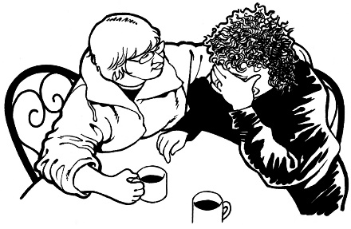
Some ways you can
awhi / support someone being bullied are by:
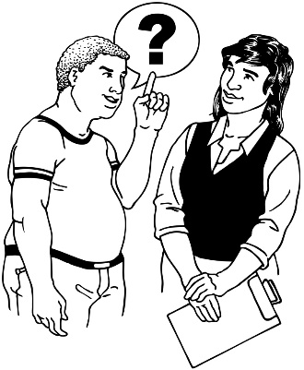
            - letting them know they are not alone
            - encouraging them to ask someone they trust for support
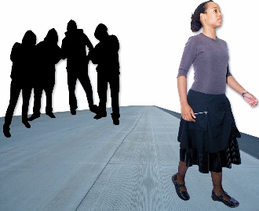
            - going with them to get support
            - helping them leave the place where they are being bullied
            - sharing online support pages with them like this website:
https://pinkshirtday.org.nz/help
- Haukotia / Distract - Interrupt the bullying in some way

Ask the person being bullied if they want to:

- go for a walk

- do something else.

Help them to leave the bullying place they are in.

Karangahia – Call it

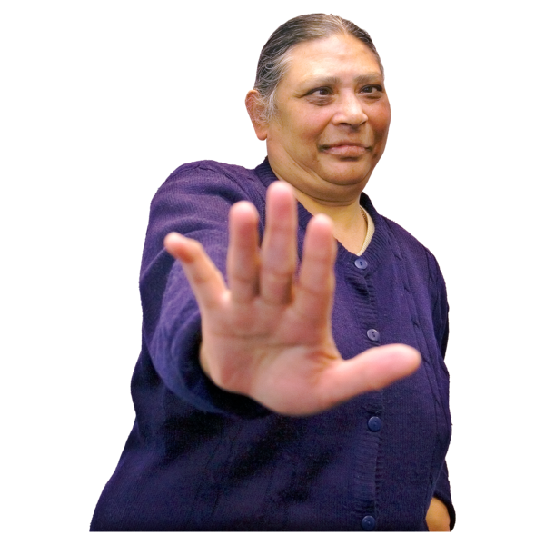
You can let the bully know they are doing something wrong.

Only do this if it is safe.


Use your words to show
aroha / kindness to the person being bullied.


It can be hard to speak up when someone around you is being bullied.

It can make a big difference if you do.

Taihoa ake, ka haumaru – Leave and act

If you do not feel safe while bullying is happening then you should move away.


Let the person being bullied know that you saw what happened.

Do this when everyone is safe.

Ask them if you can do anything to support them.


If it is safe then try talking to the person doing the bullying.

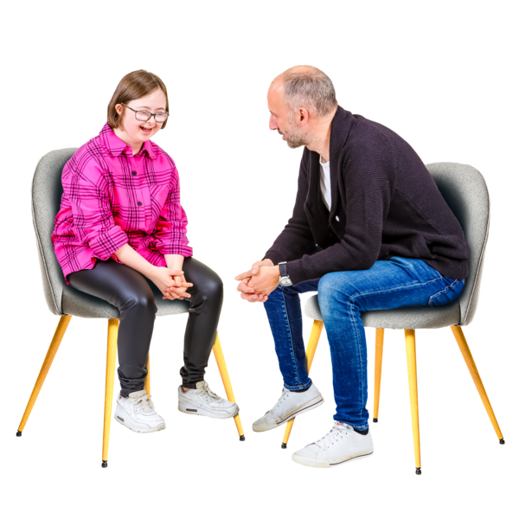
Tautokohia – Get some other help

Support the person being bullied to talk to someone they trust.

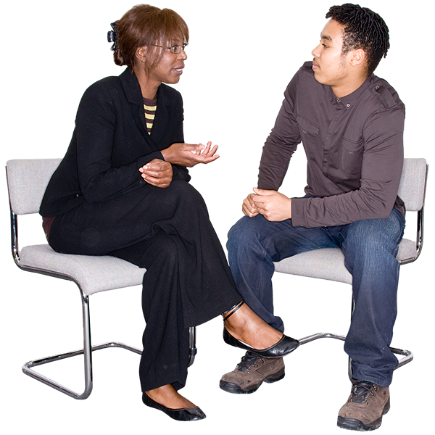
This could be:
whānau / family
kaiako / teachers

kaimahi / people you work with
a trusted friend
a helpline.

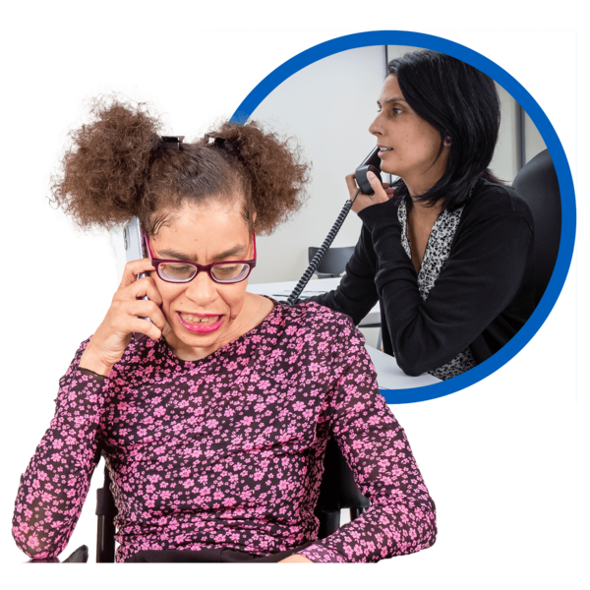
A helpline is a number you can call to talk to someone who can support you.

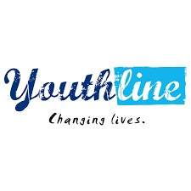
Some helplines that you can talk to are:

Youthline:
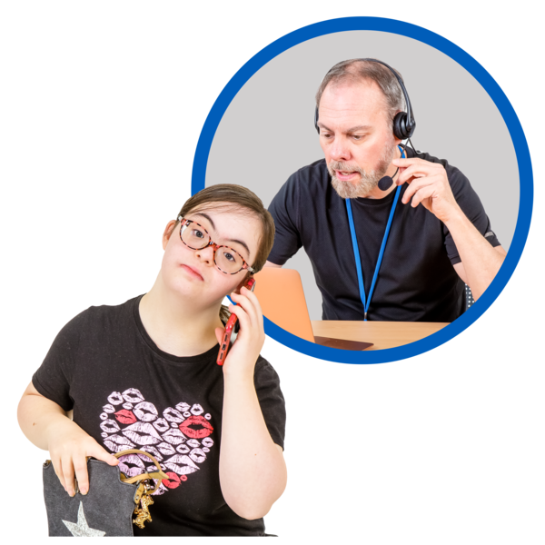
- free phone: 0800 37 66 33
- free text: 234
- webchat: https://youthline.co.nz
- email: talk@youthline.co.nz

Youthline is for:
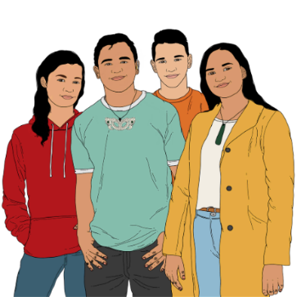
- young people
- parents
- whānau / family
- friends.

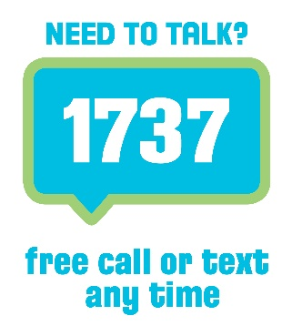
Some more helplines are:

1737 Need to Talk:
- free phone: 1737
- free text: 1737

1737 Need to Talk is for anyone who wants to talk to a trained counsellor.

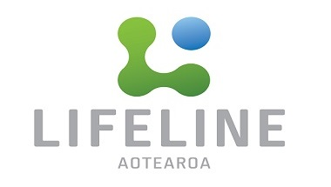
Lifeline:
- free phone: 0800 543 354
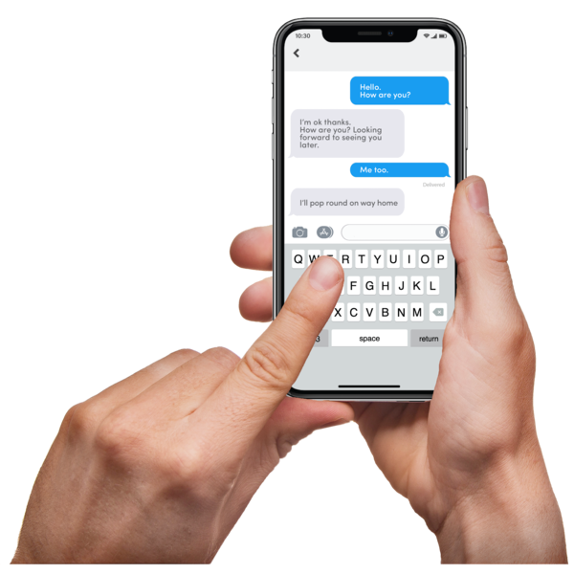
- free text: 4357

Lifeline is for anyone who wants to talk to a trained counsellor.


Some more helplines are:
- What’s Up:
  - free phone: 0800 942 8787
  - chat online:
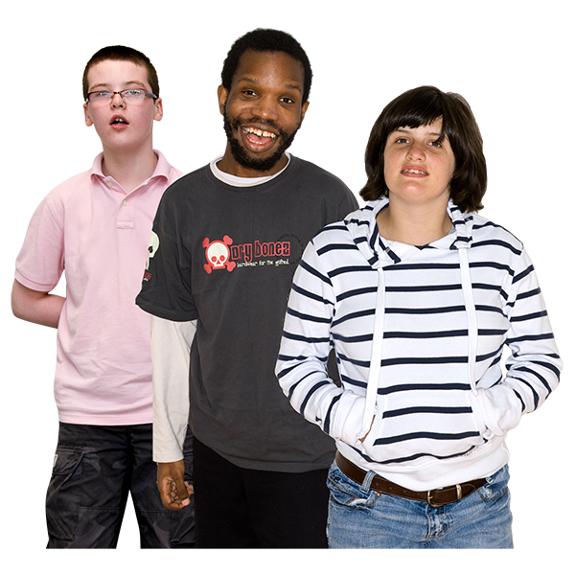
https://whatsup.co.nz

What’s Up is for children and young people.

There is a list of more helplines on this website:

https://pinkshirtday.org.nz/help

What to do if you are tamariki / child or

rangatahi / young person being bullied

Bullying is not a part of growing up.


Everyone should feel safe:
- at home
- at school
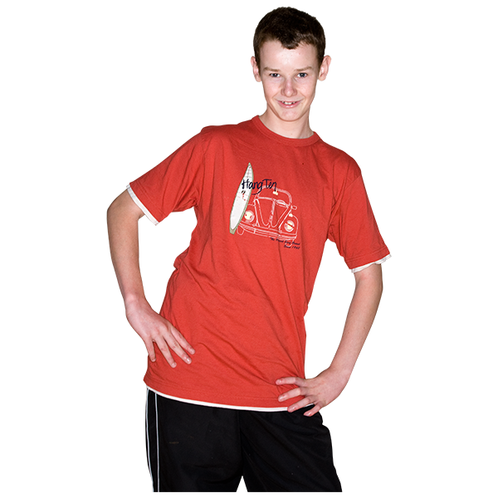
- while playing sports
- in the community.


Some things you can do to help keep yourself safe if you are being bullied are:
stay calm
walk away / move away
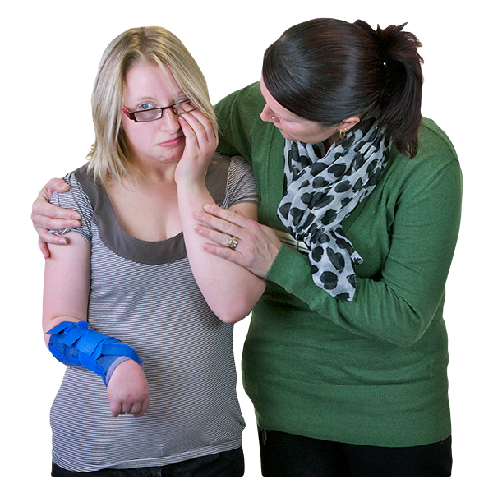
get support – tell someone you trust that you are being bullied like a:
- friend
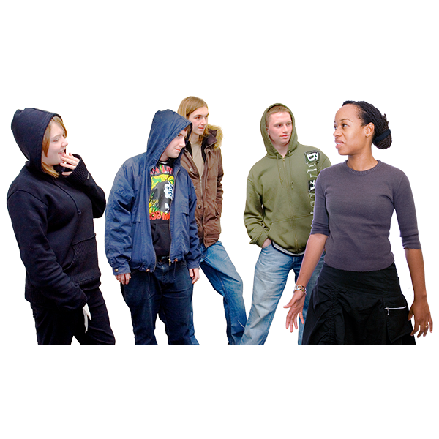
- parent
- kaiako / teacher
do not go to places that make you feel unsafe

hang around your friends.

If you are being bullied online there is information on this website that can help:
https://tinyurl.com/3255yep9

Online can mean being on a:
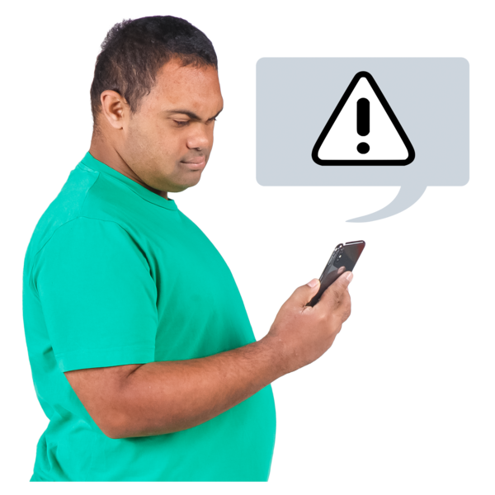
- computer
- device like an iPad / tablet
- mobile phone.

This website has information on:

what is cyberbullying
what to do if you are being cyberbullied.

Cyberbullying is when you are bullied online.

What to do if you are bullied at work


If you are being bullied at work it is important to ask for help if you:
have trouble sleeping

cannot finish your work
feel:
- sad

- anxious
- depressed
- angry
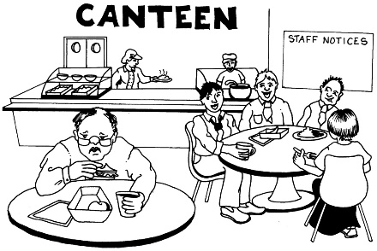
- unsafe
- like not being with some people you work with.
Information about bullying in the workplace is available on the Pink Shirt Day website here:

https://tinyurl.com/5xhp6p5j

There are things you can do to stop bullying in the workplace such as:
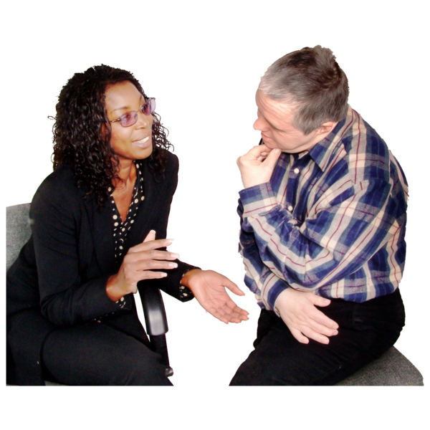
write down when you are being bullied
ask for advice / support
speak up

follow any work rules around stopping bullying
make a formal complaint.

On pages 21 to 26 we look at these things more closely.

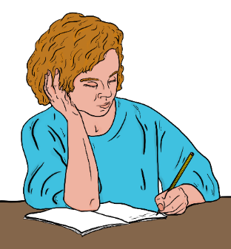
Write down when you are being bullied

Every time you are bullied you should write down:

the date
the time
where it happened
what happened
who was around you
what was said
who said what
how you felt.

Ask for advice / support

There are many people you can talk to if you are being bullied such as:
a trusted friend
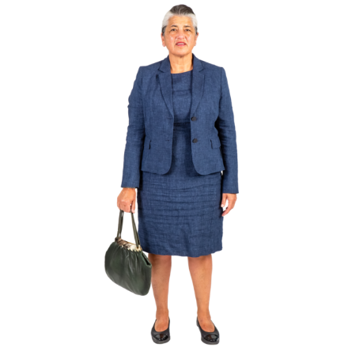
someone you work with
a manager
a union member
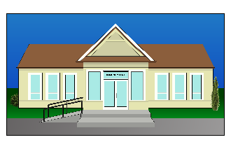
someone from an Employee Assistance Programme
your local Community Law Centre
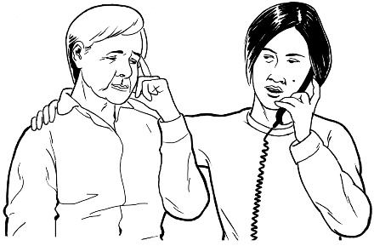
the Citizens Advice Bureau
a helpline.


A union member is someone who works at a union.

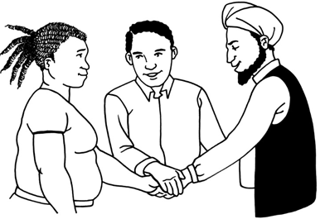
A union is an organisation that supports workers to make sure they are being treated well at work.

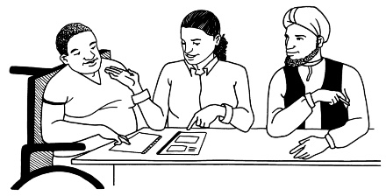
An Employee Assistance Programme is a service that supports workers with problems they have at work.

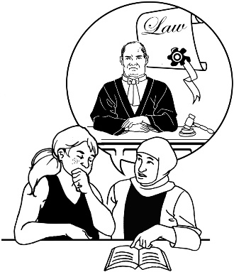
A Community Law Centre is a place that has people who can give legal advice.


You can use this website to find out where your closest Community Law Centre is:

https://communitylaw.org.nz
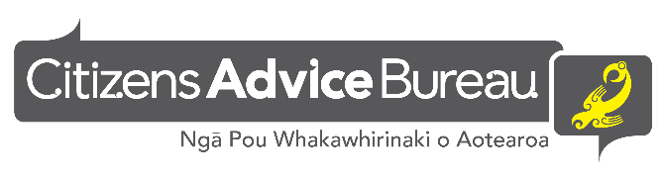
The Citizens Advice Bureau is sometimes called CAB.

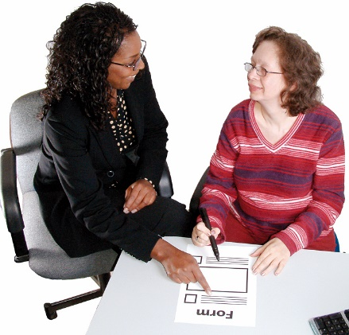
CAB can assist you to:
- understand your rights
- fill out forms.


To find out more about CAB you can:
- go to this website:
www.cab.org.nz/
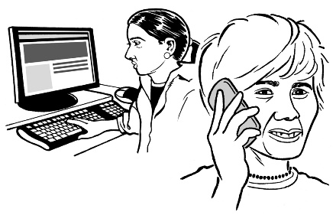
- call this phone number:
0800 367 222

Speak up
You could ask the person bullying you to stop.

Only do this if it is safe for you.


You could talk to them:
in person
by email.

Tell them:
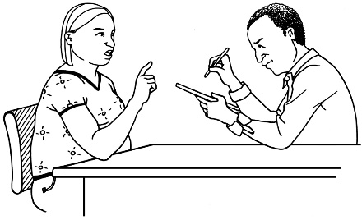
what they do that upsets you
how you would like them to speak to you.


Follow any work rules around bullying

Your workplace may already have rules around what to do if you are experiencing bullying.


Make a formal complaint

A formal complaint is when you make a written complaint about the bullying in your workplace.


Information on what should happen at your workplace after you have made a formal complaint is available on the WorkSafe website here:

https://worksafe.govt.nz/topic-and-industry/bullying/

More information

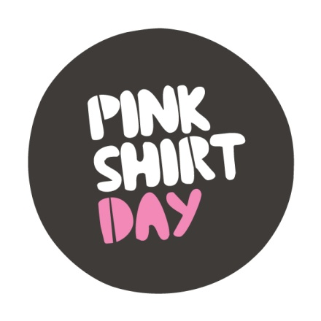
More information about Pink Shirt Day is available on this website:

https://pinkshirtday.org.nz

Information on how to contact Pink Shirt Day is available here:

https://pinkshirtday.org.nz/contact

This information has been written by the Mental Health Foundation of New Zealand.


It has been translated into Easy Read by the Make it Easy Kia Māmā Mai service of People First New Zealand Ngā Tāngata Tuatahi.

The ideas in this document are not the ideas of People First New Zealand Ngā Tāngata Tuatahi.

Make it Easy uses images from:


- Changepeople.org



            - Photosymbols.com

- SGC Image Works
- Huriana Kopeke-Te Aho
- T. Wood.

All images used in this Easy Read document are subject to copyright rules and cannot be used without permission.

